Home Tempature Adjustment System
Software Requirements Specification
For Home Tempature Adjustment System

Prepared by Ahmet Talha Sivrikaya
24.04.2026
«Page Break»

Table of Contents
«Table of Contents»
Revision History
Name | Date | Reason for Changes | Version
Ahmet Talha Sivrikaya | 24.04.2026 | ”Initial version” | «1.0»
Ahmet Talha Sivrikaya | 24.04.2026 | “Functional and Nonfunctional Requirements Added” | 1.1
Ahmet Talha Sivrikaya | 24.04.2026 | “User Class UML Diagram Added” | 1.2
Ahmet Talha Sivrikaya | 24.04.2026 | “UML Class Diagram Added” | 1.3
Ahmet Talha Sivrikaya | 24.04.2026 | “UML Activity Diagram Added” | 1.4
«Page break»

1. Introduction
1.1. Purpose
1.2. Document Conventions
1.3. Intended Audience and Reading Suggestions
1.4. Product Scope
1.5. References
2. Overall Description
2.1. Product Perspective
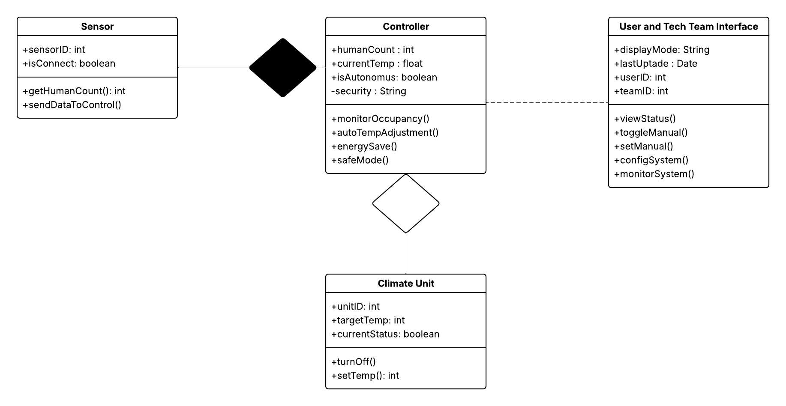
2.2. Product Features
2.3. User Classes and Characteristics
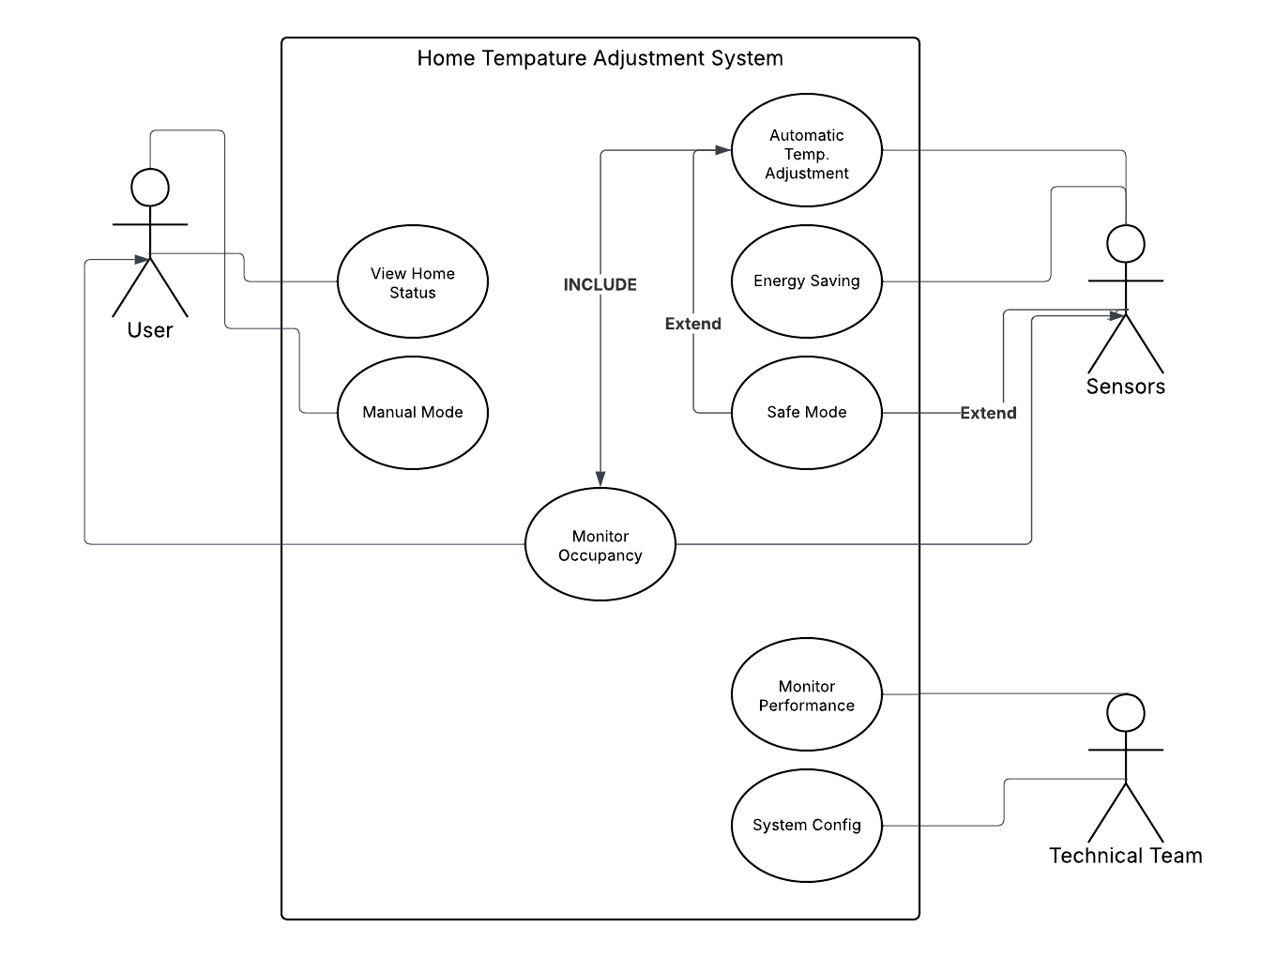
2.4. Operating Environment
2.5. Design and Implementation Constraints
2.6. User Documentation
2.7. Assumptions and Dependencies
3. System Features
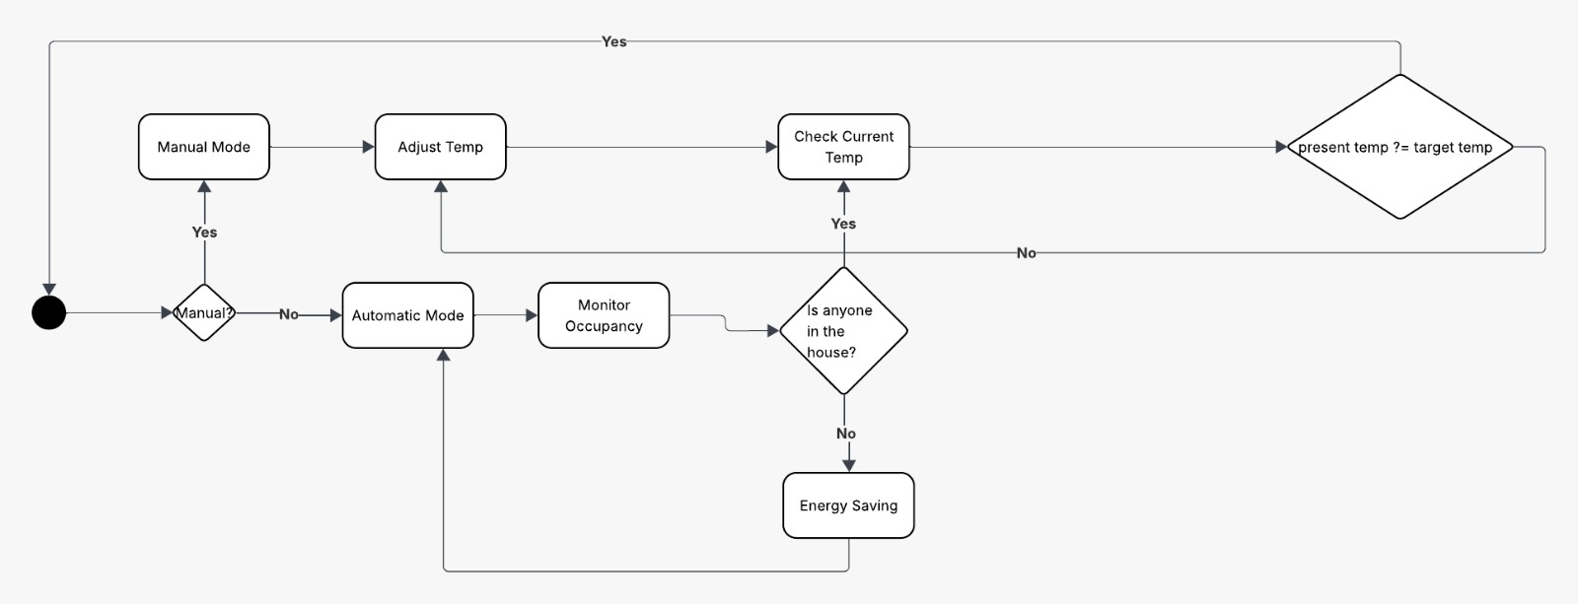
When the system is turned on, the user is given the option of Manual or Automatic mode. In automatic mode, the system constantly monitors the occupancy rate in the house. If there is no one at home, it switches to 'Energy Saving' mode; If someone has it, they adjust the air conditioning unit until it reaches the target temperature.

4. External Interface Requirements
4.1. User Interfaces Overview
4.2. Hardware Interfaces
4.3. Software Interfaces
5. System Features/Modules
5.1 System Feature Name
5.1.1. Description and Priority
5.1.2 Stimulus/Response Sequences

5.1.3 Functional Requirements
REQ-1.1: System shall detect human count in the house using sensors.
REQ-1.2: When human count in house is zero system, shall turn of the all climate units
REQ-1.3: When the number of people in the house increases or decreases, the system shall dynamically adjust the temperature.
REQ-1.4: The system shall allow the user to disable autonomous mode and enter manual temperature via the interface
REQ-1.5: If the sensor is disconnected, the system shall enter safe mode and operate at a standard temperature (e.g. 21°C).

6. Nonfunctional Requirements
6.1. Performance
NF-1.1: The system shall process the data from sensors < 3 seconds and send commands to the climate units.
NF-1.2: The situation of house shall recorded securely using encryption.
6.2. Security
NF-2.1: The system shall start automatically after the blacouts.

